[1]

Design and Implementation of a Mobile Peer-to-Peer Crowdsourcing Platform

Gongbin Guo

*Abstract*—Crowdsourcing platforms have been really popular in recent years. People from all over the world can ask and solve questions at anytime and anywhere they want. From the standpoint of the people who ask questions, they could get answers that are beyond their expectations and then think outside of the box. From the standpoint of the people who answer questions, they could gain personal accomplishment and sometimes make money from it. In this lab, two properties are added to the crowdsourcing platform. The first one is real time property. This means that a task has to be answered within time limit which is specified by the task, otherwise the owner of the task may not need the answers anymore like in the scenarios mentioned in the introduction section. The basic idea of real time is that users need instant help from the Internet, not the help after two or three days later. Old tasks are not displayed on the platform, which means a filter on the time is applied. The second is the location that is also termed as geographical information. So every task is associated with geographical information so that users can find tasks that are near to them. People can more easily provide information on things they are around them. This would improve the quality of the answers. Users who can get accurate answers are willing to use this crowdsourcing platform again and pay more. So this is beneficial for both the worker and the requester.

# INTRODUCTION

C

rowdsourcing platforms help individuals or organizations to obtain needed services or ideas. Although crowdsourcing was coined as a portmanteau of crowd and outsourcing, actually it is not outsourcing. Outsourcing means the hired people provide the specified work within a specific time span. It emphasizes on the speciality of the people. Crowdsourcing platforms distribute work among people from the Internet. It takes advantage of diversification of the human resource. The people from the Internet are undefined, the background, the experience, the culture and so on. They could be professionals or amateurs. No constraint is set. This is to lure people to cooperate and innovate.

In this lab, two things are added to the crowdsourcing platform. The first one is real time. This means that a task has to be answered within time limit which is specified by the task, otherwise the answers probably are not needed anymore. By doing this, people get timely feedback from the people on the Internet. This is for the people who are in agent need for help. On the other hand, real time also means that old enough tasks are usually not displayed on the platform, which means a filter on the time is applied. For example, tasks that are two or three days old usually are not displayed on the platform. So the basic idea is that users need instant help from the Internet, not the help after two or three days later. So basically tasks that are beyond the requirement of the time limit are not displayed even though they have not been answered yet, however people could set this filter in the Settings tab of the App. The second is the location that is also termed as geographical information. So every task is associated with geographical information. People look around the tasks that are near to them and answer the tasks that are interested to them. What’s more, people know things that are around them better. Thus, to a large extent, the quality of the answers is maintained. So this is beneficial for both the worker and the requester.

These two make this platform different from others. This platform focuses on timely help from others. People who are in urgent help may really need this platform. It probably narrows down the potential users of this platform, but on the other side, this platform could achieve better quality of answers.

In the following several scenarios are described, the tasks mentioned in these scenarios have to be performed on a timely basis in the real world, and also, they should be performed in a specific location.

Scenario 1: Travelling help on demand

Tom needs to work for a week in Nanjing, China. One day after work, he wants to try different delicious food and to buy several traditional souvenirs for his parents. He decides to go to the FuZi temple which is famous for food and souvenirs. But he does not speak Chinese and so he needs help. With the help of this platform, he could find a native who speaks English to help him.

Scenario 2: Book availability in library

John needs to do a presentation a few days later. And he needs to borrow a book from the Darmstadt city library. But he does not know if it is available. If it is not available, he needs to find something else for help. So he asks about this on this platform. A few minutes later, he gets an answer.

Scenario 3: Registration information in university

Mary is Turkish and she is really happy to get enrollment letter from TU Darmstadt. But she needs to know where the registration office, the accommodation office and the foreigner office are and several other things need to keep in mind. So before she goes to Darmstadt, she posts a question on this platform, and she gets a lot of feedbacks.

These scenarios are normal cases that could happen every day. All tasks aforementioned are location-dependent and should be done within the specified time constraint. Currently there is no dedicated platform aiming at solving these kinds of tasks. This platform particularly deals with this problem.

# Related Work

This lab requires to build an app that features question-and-answer functionality. There are two apps that are used for reference. The first one is Quora[2] which is a question-and-answer site where questions are asked, answered, edited and organized by its community of users. The other is Zhihu [3] that is a Chinese version of Quora. This lab is also about question-and-answer, so when designing this app, I borrowed the design style of the two apps. There are four tabs in my app. This is similar to the two apps. They have the same interface design. This is described in system design. But neither of them features real time and location that I discussed earlier.

Location-based Crowdsourcing: Extending Crowdsourcing to the Real World (Florian Alt, 2010) introduces system architecture of a location-based question-and-answer app. There are three components in this architecture. A web interface is used for creating tasks and a server including a database and client application. It also gives an overview of all the tables that are going to be created in the database. The tables are described in system design section. The architecture is refined and is explained in the system design and implementation section.

# system requirements

From the several scenarios mentioned above and the related work, some generic requirements can be drawn.

The app should be able to create tasks for users. And when creating a task, two things have to be specified. One is description of the task, the other is geographical information associated with the task. These two properties are mandatory.

Users should be able to search locations when creating a task. For example, John needs to specify the library as the location of his task. So he should be able to search where the library is instead of figuring it out himself.

The app should also let users view the tasks they have created and have answered. This is convenient for users to access the tasks later on.

# system design

Figure 1 shows the system architecture. The platform consists of two components: (1) app on mobile devices for users to create tasks and answer tasks, (2) server which is Google Firebase[4] including database for storing tasks and retrieving tasks.

Server and database

In terms of the database, the traditional setup of Oracle and MYSQL was not used, currently there is a more flexible and modern approach that is provided by Google firebase, which is especially for client-server model based Mobile apps. So the database I use for this app is Google Firebase. Firebase is a mobile and web application platform with tools and infrastructure designed to help developers build high-quality apps. Firebase is made up of complementary features that developers can mix-and-match to fit their needs. I spent some time digging into it and found that it can be used to support this app. It supports database, authentication, storage, notification and more. There are a lot of APIs on firebase.google.com that I can refer to when I develop this app.

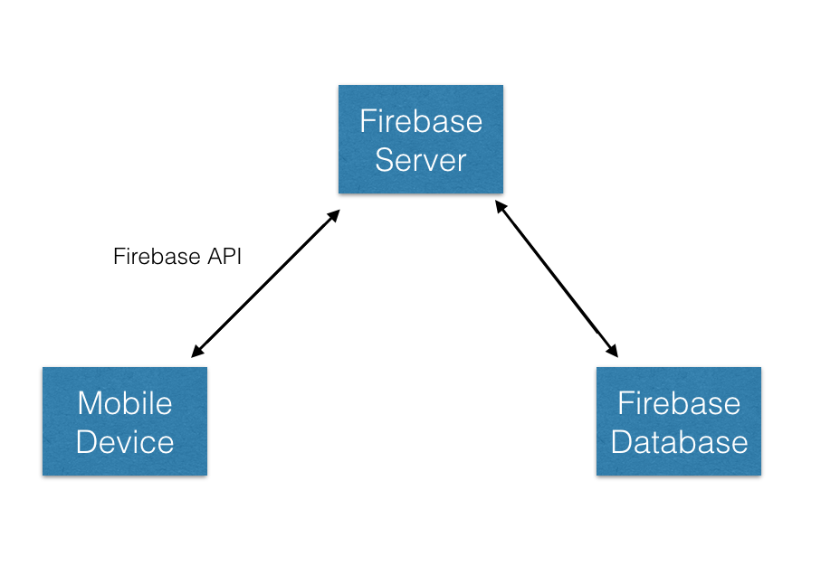

Figure 1: the system architecture

Mobile devices

The mobile platform here used is IOS. It is one of the most advanced mobile operating software. Most of frameworks are kept updated so it’s easy for developers to develop and maintain. MapKit framework and CoreLocation framework are the most frequently used ones for developing geography related apps.

Communication between server and client

Google Firebase provides a set of APIs for communication between Firebase Server and apps.

Data Models

There should be three main models in this app, which are Task, Person and Answer. Each of the property is explained in the table.

|  |  |
| --- | --- |
| name | an user’s display name |
| locations | User’s favorite locations stored online |
| image | An image for displaying an user’s image profile |
| uid | A handle for getting the location of this user record that is stored on the firebase |
| email | The email for the use to sign in |

Table1: Person Table

|  |  |
| --- | --- |
| person | the person who submits the task |
| summary | The summary of the task |
| time | Time when this task is submitted |
| location | The location information associated with the task |
| answers | The answers for this tasks if any |
| coordinate | Latitude and longitude |
| taskReference | A handle that specifies the task online |
| taskKey | the string that specifies the task online |
| title | The title of the task |
| subtitle | The subtitle of the task |

Table 2: Task Table

|  |  |
| --- | --- |
| person | the person who answers a task |
| answer | the answer of a task |
| time | the time a person answers a task |

Table 3: Answer Table

Figure 2 shows the entire interface of this app. And the main design pattern used in this app is Model-View-Controller. When users sign in, the main screen of the app will show up. There are four tabs on the main screen. They are Tasks, Maps, Search and Settings. So the Tasks tab is used to show all the tasks that are created by users. The Maps tab is used to show all the tasks on a map. The Search tab is used for searching for a specific place. The Settings tab is used to keep user’s settings. The four tabs together can fulfill all the requirements mentioned in the system requirements section.

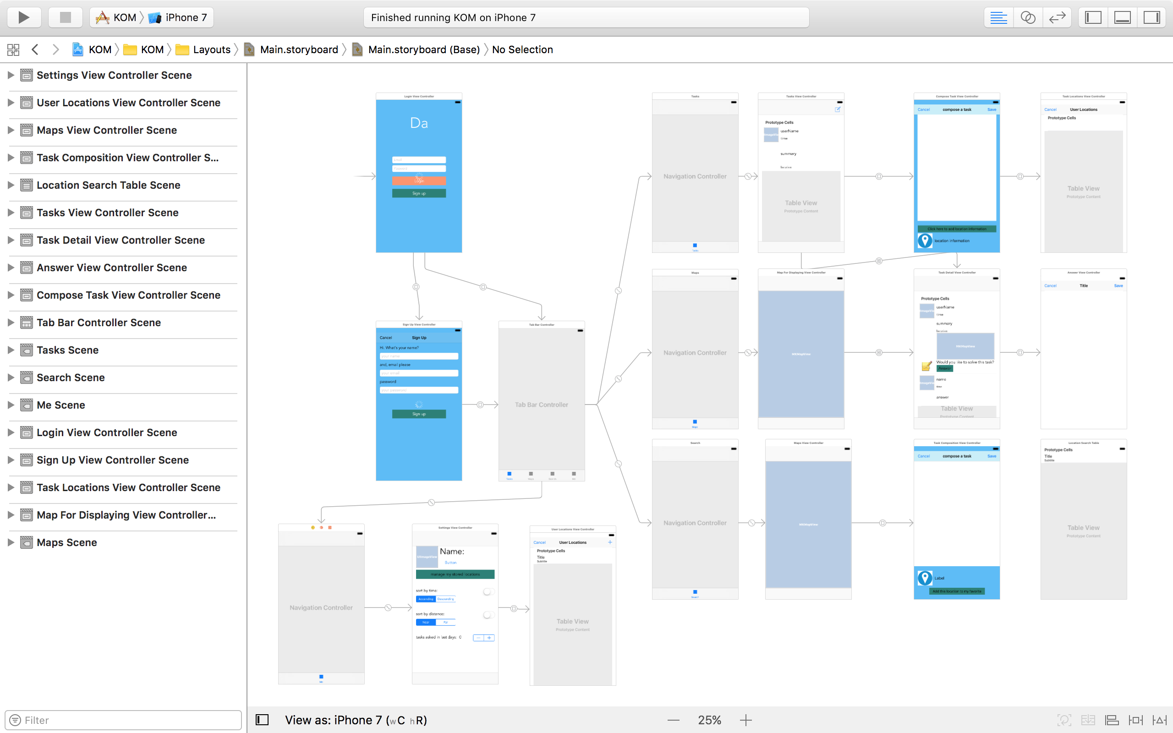

Figure 2: The Interface of This App

With regard to the design decisions, first, this mobile app can be used both by seekers and workers. Every user could be a seeker that may have problems needed to be solved and at the same time a worker that would like to solve problems for others. Second, a graphical map is provided to the users to specify their location information. This allows for creating tasks not only based on the current location but also based on other locations. For example, users could use the map to find their desired location and ask a question in terms of that specific location. Third, location information should be converted to human-readable text. A pair of latitude and longitude is only for machines and not for users. Human-readable location address provides better usability.

# Implementation

Figure 3 shows what the Tasks tab looks like. In the Tasks tab, Tasks Scene is managed by Tasks View Controller. When the Tasks Scene is first showed up, the app will connect to the server and fetch the tasks created by users and then it will load up the table view with the fetched results. For each cell of the table view in the Tasks Scene, there are user name by who this task is created, image profile of the user, time that the task is created, summary of the task and location that is associated with the task. Users can tap on one of the tasks to see the detail of it and then decide whether to answer it or not. The Task Detail Scene shows the detail of a task and it’s managed by Task Detail View Controller. All the details will again show up in this scene plus the answers if any. There are user name and time that the answer is submitted and the answer itself for each answer. If a user decides to answer that specific task, the Answer Scene will show up and it’s managed by Answer View Controller. There is a text view in Answer Scene. Users can type their answer there and click the save button to submit it to the server if they want to answer this task. After submitting their answer to the server, the app will go back to the previous scene which is Task Detail Scene so that this user can instantly see the answer on the app. And other users can also see the updated answer on their phone. If users decide to not answer this task and want to cancel it, they can click the cancel button on the left-top of the scene. The app will go back to the previous scene. There is another functionality in the Task Detail Scene. Users can create tasks by clicking on the right-top button. This will load up the Compose Scene. And it’s managed by Compose Task View Controller. Here users can create a task that they want to ask. There is a button that reminds users to add location information to the task. Task Locations Scene will load up if users click on the button. It’s managed by the Task Locations View Controller. It shows the user’s favorite locations that are stored previously when they created other tasks. Clicking on one of the locations will select it and navigate to the previous scene. The location information will be added and displayed in the Compose Task Scene. Again there are two buttons in this scene, cancel and save button.

Figure 4 shows what the Maps tab look like. In the Maps tab, Map For Displaying Scene is responsible for displaying a graphical map and showing tasks. It is managed by Map For Displaying View Controller. Tasks are represented as pins on the map. Users can click on the pin then a small label pops up with location information displaying on it, as well as name of the user who created it. There is also a callout accessory button on the pin. The detail of the specific task associated with the pin shows on the Task Detail Scene if users click on that pin. It is the same scene as described previously. Users can perform the same actions within that scene as described previously.

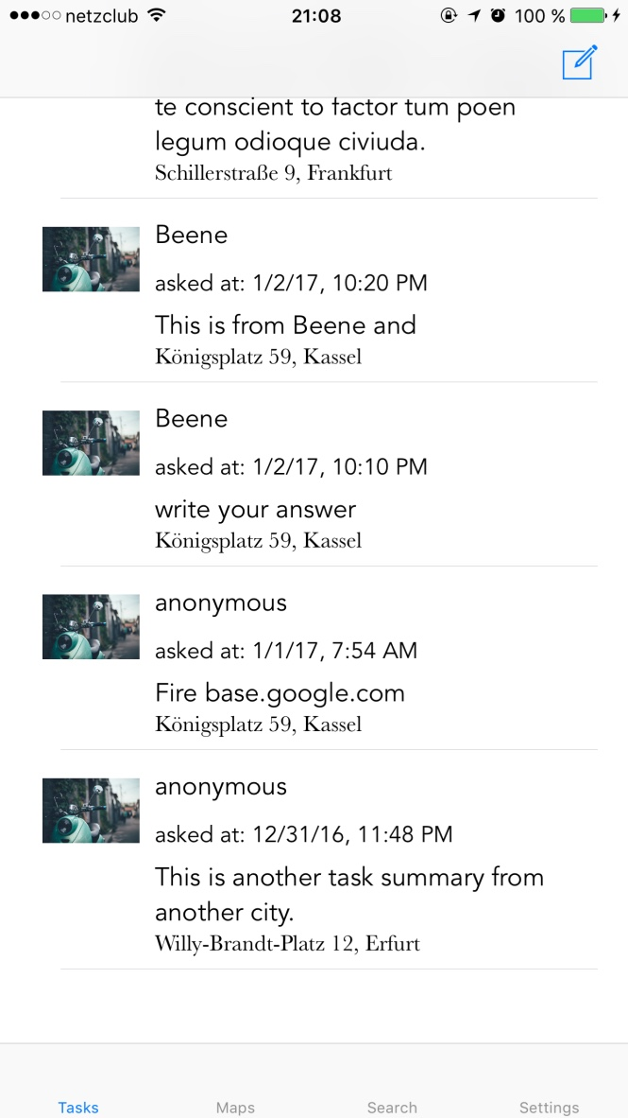 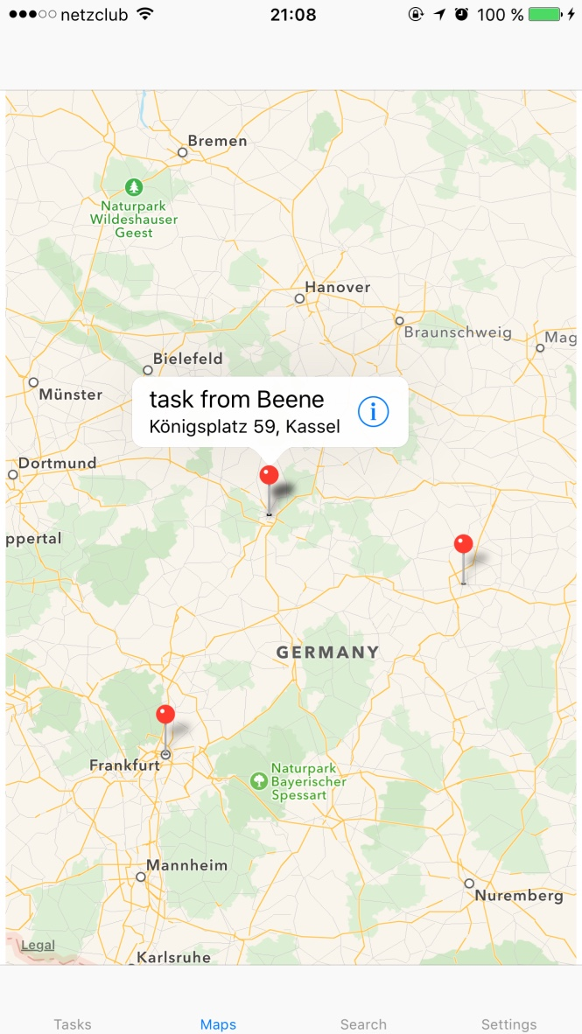

Figure 3(left): the Tasks tab

Figure 4(right): the Maps tab

Figure 5 shows what the Search tab looks like. In the Search tab, Maps Scene is used for displaying a graphical map and searching for a location that matches user’s need. It is managed by Maps View Controller. There is a search area on top of the scene. Users can use the searching function to find an address that best suits their task that they are going to create. When searching, a list of possible matches shows in another scene. It is displayed by Location Search Scene which is managed Location Search View Controller. The two view controllers work together to achieve the searching functionality. Here delegation design pattern is used in order to make them work seamlessly. When clicking on one of the available results, a pin will be dropped on the map. Clicking on the pin will show name of the location associated with the pin as well as the address. There is also a callout accessory button on the pin that will lead to creating a task with the location preset. The scene for creating a task is called Task Composition Scene which is managed by Task Composition View Controller. There is a button in this scene, which is used to add the location to the user’s favorite location list. So next time, this user can create a task by just choosing one of his or her favorite locations, without searching for it.

Figure 6 shows what the Settings tab looks like. In the Settings tab, Settings Scene is used for managing the app settings. Users can turn on or off the sorting functionality. Users can sort the tasks by time that the tasks are created and by distance. The distance is calculated from the user’s current location to the task’s location. Users can also specify the filter that filter out tasks that are pretty old. Be default, when users first load up the Tasks Scene, no filter is applied and no sorting is applied.

So in a nutshell, the Tasks tab is used for displaying tasks in a table view. Users can view the tasks and choose the one they like to answer. The Maps tab is used for displaying tasks in a graphical map. Tasks are represented as pins that users can click them to perform actions with the task associated with the pin. The Search tab is used for searching for a location and then creating a task with the location. The Settings tab is used for setting user’s preferences.

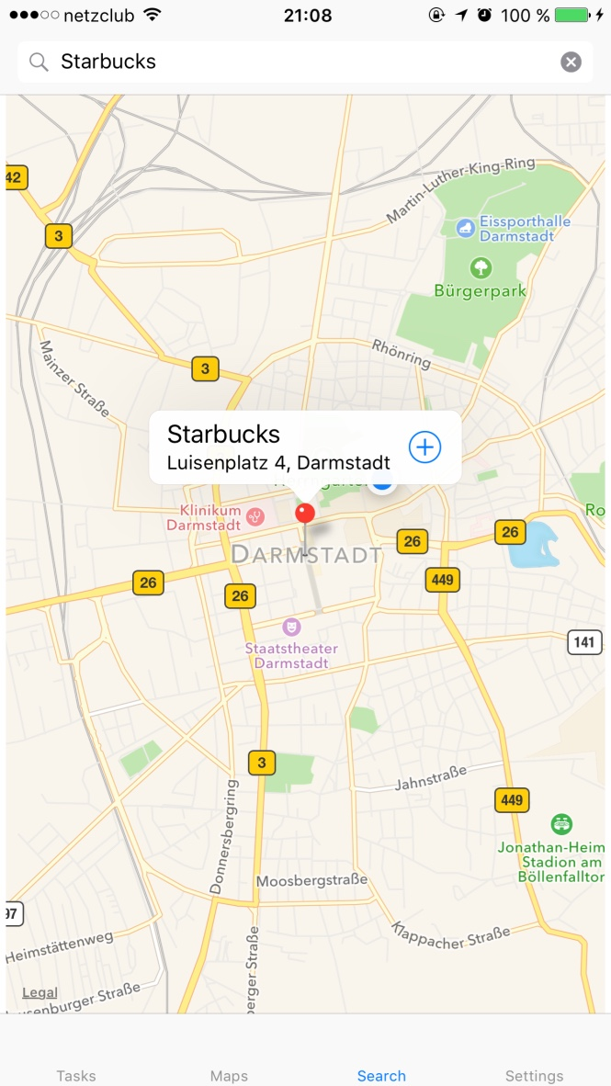 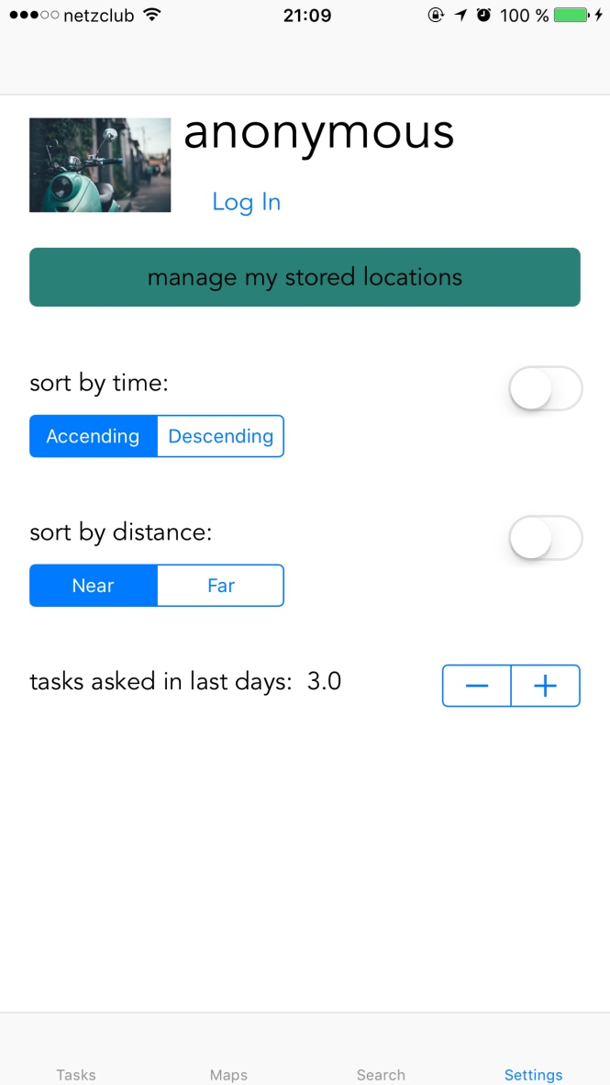

Figure 5(left): the Search tab

Figure 6(right): the Maps tab

So there are basically two ways for users to create tasks. One is using the top-right button on the Tasks tab. When creating tasks on this tab, users have to use their location that are previously stored, otherwise users can’t create tasks in this way. The other way to create tasks is on the Search tab. Users need to search for a place first in order to create their task. The reason why I am doing this is to make creating tasks simple. Most of the time, Users first search for a place and then create a task. If users don’t have favorite location addresses, users have to type text and select the matched address. This process would be annoying if they want to create tasks with their favorite location address each time. Providing an alternative in this case is good for users to improve the efficiency. And there are also two ways for users to view tasks. One is using the Tasks tab. The table view in the Tasks tab is used to display all the tasks. Users can select one of them to view the detail of it and then decide whether to answer it or not. The other way is using the Maps tab. Tasks are represented as pins showed on the map so that users know where exactly the tasks is located. And what’s more, the graphical interface is also more friendly to users

In terms of the database, the reason why I didn’t choose to use traditional database, like Oracle, mysql and so on is that I like new technologies. So the database I use for this app is Google Firebase. Firebase is a mobile and web application platform with tools and infrastructure designed to help developers build high-quality apps. Firebase is made up of complementary features that developers can mix-and-match to fit their needs. I spent some time digging into it and found that it can be used to support this app. It supports database, authentication, storage, notification and more. There are a lot of APIs on firebase.google.com that I can refer to when I develop this app.

This app needs to know the identity of a user. Knowing a user's identity allows an app to securely save user data in the cloud and provide the same personalized experience across all of the user's devices. The authentication type that is used for this app is email and password based authentication. The Firebase Authentication SDK provides methods to create and manage users that use their email addresses and passwords to sign in. The method is

createUserWithEmail: email: password: completion:

The completion handler is used to handle the result whether creating a user is successful or not. If it is successful,

signInWithEmail: email: password: completion:

method is called to sign in the user. There is also a completion handler to deal with the result of this signing in process. These two methods are mainly associated with the LogIn scene and SignUp Scene. In both cases, there is one detail that needs to be handled. The interaction with the view should be disabled when a user clicks on the Login or Sign Up button. The code

view.isUserInteractionEnabled = false

is used to handle this.

When the app loads up, it connects to the firebase database to fetch the tasks. To read or write data from the database, an instance of FIRDatabaseReference: is needed.

let ref = FIRDatabase.database().reference()

is used to get the root of the database. And then use the

child(_ pathString: String)

method to get the child reference. To read data at a path and listen for changes, use the

observeEventType:withBlock orobserveSingleEventOfType: withBlock methods of FIRDatabaseReference to observe FIRDataEventTypeValue events.

The FIRDataEventTypeValue event is used to read the data at a given path, as it exists at the time of the event. This method is triggered once when the listener is attached and again every time the data, including any children, changes. So this method is perfect for loading the tasks and then listening for any changes when the app first launches. And this can be done in

viewDidLoad()

method which is called only once in the lifecycle of a view. In terms of sorting and filtering the tasks,

viewWillAppear()

is more appropriate which is called every time a view appears on the screen. Filtering should always be executed before sorting because of efficiency. And a user has to pull down the table view to trigger the filter action. Because each time a filter is applied, the app needs to connect to the firebase to fetch the tasks and then check if each task should be filtered out. When filtering tasks, each time associated with its task is calculated with current time to get the difference. There are two methods in regard to sorting the tasks, sort by time and sort by distance. But only one of them can be applied at a time. They are conflicted to a great extent. When sorting by distance, the location for the app has to be turned on, otherwise the app couldn’t get the user’s current location. The distance is calculated from the location of the task and the user’s current location. And then comparing all of the distances would get the sorting result. Regarding the table view cell, the height of it should be adjusted to the length of the summary. And there is a delegate method in

UITableViewDelegate tableView(_ tableView: [UITableView](apple-reference-documentation://hs8FRRfKne), estimatedHeightForRowAt indexPath: [IndexPath](apple-reference-documentation://hstjcvutpS)) -> [CGFloat](apple-reference-documentation://hswJZ0A9na).

This method is used to calculate the dynamic height for each cell based on the length of each task. Data types that can be set on firebase are:

NSString, NSNumber, NSDictionary and NSArray.

So when writing data to the firebase, all of the data have to be converted. Because firebase doesn’t know the local type of data used by Swift. I made all of the converted type to be Swift type of Any, to be more specific, for example, the method below shows how I convert Task type to Any which actually is NSDictionary type that can be used to store data on firebase. all other types that need to be converted use a similar conversion method.

func toAnyObject() -> Any {

return [

"personName": person.name,

"summary": summary,

"time": time,

"latitude": location.latitude,

"longitude": location.longitude

]

}

As required, each task must have a location with it. A location is actually a pair of latitude and longitude. But this isn’t readable for human beings. So I convert the location to human-readable text, for example, Luisenplatz 4, Darmstadt. There is a class called CLGeocoder that can be used to deal with it. The method

func reverseGeocodeLocation(_location: [CLLocation](apple-reference-documentation://hs-aCpUKrN), completionHandler:escaping [CLGeocodeCompletionHandler](apple-reference-documentation://hszeSZOBEv))

submits a reverse-geocoding request for the specified location.

In the Search tab, there are two different scenarios. If the user’s location for this app is turned on, the map will use the user’s current location as the center of the map and zoom in with the amount of north-to-south distance of 4000 meters to use for the span. Otherwise, the map just shows the default country where the app is used, for example, Germany. When searching for a location, the class MKLocalSearchRequest is used for processing the user’s input. The map region of this class is the same as the currently displayed region of the map view. The returned result of the request is used to fill up the location search scene that is showed on top the map. Clicking on one the results shows a pin on the map. The location search table view couldn’t handle this job, it’s the map’s responsibility to do this. So a delegation is used here. The map view controller needs to extend the protocol below to handle the pin. An instance of MKplacemark is passed in and it’s one of the possible matching results displayed in the location search table view.

protocol HandleMapSearch {

func dropPinZoomIn(placemark: MKPlacemark)

}

As of the pins showed on maps, they are actually reused for the sake of scarce memory. A delegate method

mapView(_ mapView: MKMapView, viewFor annotation: MKAnnotation) -> MKAnnotationView?

has to be used to deal with problem. And actually the table view cell of a table view is also reused. The corresponding method is

tableView(_ tableView: UITableView, cellForRowAt indexPath: IndexPath) -> UITableViewCell.

When writing an answer or writing the summary for a task, there are some method that I use to deal with the placeholder and automatic showing up and hiding of keyboard. This is for convenience’s sake. These method are all declared in UITextViewDelegate. And the methods are

textViewShouldBeginEditing(textView: UITextView) -> Bool

textViewDidChange(_ textView: UITextView).

# conclusion

This app is capable of performing creating tasks and answering tasks. It supports all the requirements mentioned in the system requirements section. However, there are still some improvements that can be done to enhance this app. Such as, the log in and log out features are not implemented. In terms of interacting with this app, there are no complicated prompt messages. And the steps for both creating and answers tasks are pretty low. Users know what to do without extra hint. They can use this app without any obstacles. Scalability issue is not considered since it’s beyond the scope of this project. However, there are scalable methods that can be used to deal with the data that loads up the table view if the amount of the data is pretty high.

The aim of this lab is to develop a mobile Peer-to-Peer crowdsourcing platform. Particularly, two fundamental properties need to be achieved, which are real-time and geographical information. Through looking into some of related work and delving into development, now the app is capable of achieving aforementioned requirements. However, this app is not a one-size-fits-all application. This app is intended for tasks that are in urgent need and are associated with geographical information. And also, there is always room for improvement. People who are interested in this kind of app can extend this app. For example, in the Settings tab, showing a list of tasks that a user has asked could be regarded as a feature. Another feature, like this app could let anonymous users ask questions and answer questions.

References

1. [www.quora.com](http://www.quora.com)
2. [www.zhihu.com](http://www.zhihu.com)
3. firebase.google.com
4. Florian Alt, Alireza Sahami Shirazi, Albrecht Schmidt, Urs Kramer, Zahid Nawaz, Location-based Crowdsourcing: Extending Crowdsourcing to the Real World, [NordiCHI '10](http://www.nordichi2010.org/) Proceedings of the 6th Nordic Conference on Human-Computer Interaction: Extending Boundaries, 2010
5. Model-View-Controller: <https://developer.apple.com/library/content/documentation/General/Conceptual/DevPedia-CocoaCore/MVC.html>
6. Jonathan Kaplan, William Crawford, “J2EE Design Patterns”, O'Reilly Media, Inc. 2003

1.
2. www.quora.com
3. [www.zhihu.com](http://www.zhihu.com)
4. firebase.google.com